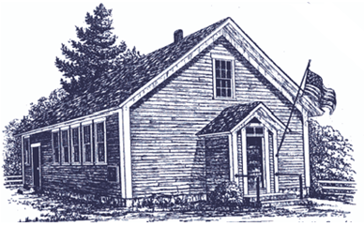

Landaff Blue School

813 Mill Brook Rd

Landaff, NH 03585

Tel: 603.838.6416

Molly Culver, M. Ed Teaching Principal

April 25, 2023

Asbestos Management Plan

Annual Notice of Availability

To Staff, Parents/Guardians, and Students:

This notice serves to fulfill annual notification requirements in accordance with Section 763.93 of the *Asbestos Emergency Response Act* (AHERA). AHERA requires that all school buildings be visually inspected by accredited inspectors to identify all asbestos-containing building materials (ACBM) that may be present in the school environment. As required under the AHERA, Landaff Blue School must maintain an Asbestos Management Plan (AMP) and keep the AMP on file at the school, and the School Administrative Unit Office. The AMP is available for review during school hours, Monday through Friday.

Periodic surveillance of known asbestos in Landaff Blue School is performed every six months by a designated person to assess the condition of the ACBM. Six-month Assessment Results are maintained and are also available for review in AMP.

For additional information, please contact our Local Educational Agency Designee, Molly Culver at 603.838.6416, or [m.culver@sau35.org](mailto:m.culver@sau35.org)

Sincerely,

Molly Culver, M. Ed Teaching Principal

Landaff Blue School